Solve Your Child’s Sleep Problems- Book Summary

By Lily Talley

Does your child have difficulty falling asleep or waking up in the middle of the night? Have you ever wondered how much sleep your child needs to be getting? Author Dr. Richard Ferber tackles these questions with the book Solve Your Child’s Sleep Problems. This is a 404-page book that every parent should own and I highly recommended it.

Dr. Ferber is an associate professor of neurology at the Harvard Medical School and director of the Center for Pediatric Sleep Disorders at Children’s Hospital Boston. He is widely known as the nation’s foremost authority on children’s sleep problems. This book summary will discuss the sound ideas for helping your child fall and stay asleep at night so that they perform well during the day. The following information applies equally to both girls and boys.

The book summary is divided into the following sections:

- At the End of Your Rope
- Helping Your Child Develop Good Sleep Practices
- Should You Co-sleep?
- The Nighttime Crying Problem
- Nighttime Fears
- Bed-wetting
- General Advice

At the End of Your Rope
Parents face many common problems which may include frequent difficulty falling asleep at bedtime, waking during the night with an inability to go right back to sleep without parental support or intervention, waking up too early or too late in the morning, falling asleep too early or too late in the evening, or being excessively sleepy during the day. Additional problems may also include sleep terrors, sleepwalking, and bedwetting. It’s important to learn how to prepare for and deal with these potential issues.

Total sleep time per twenty-four-hour period starts at around 16 hours, and slowly diminishes, as the child gets older. Some children nine-months old may sleep nine hours and take two solid 90 minutes naps, or they may sleep close to 12 hours at night and briefly nap during the day. Even if your two year old only sleeps about 8 hours and seems fine during the day, the child is probably not getting enough sleep. If you can make some appropriate changes to add a few hours of sleep, your child will probably be happier in the daytime, less irritable, and less inclined to arguments and tantrums. Adolescents on the other hand almost never get enough sleep. When adolescents have the opportunity to get as much sleep as they want, they average about nine to ten hours per night, which is optimal for their age.

Overall, children should fall asleep quickly, sleep well at night, wake spontaneously or easily in the morning, and nap only as appropriate for their age. If they do all of these things, they are probably getting the right amount of sleep.

The chart below will show you the average amount of sleep children get at various ages during naps and nighttime sleep.

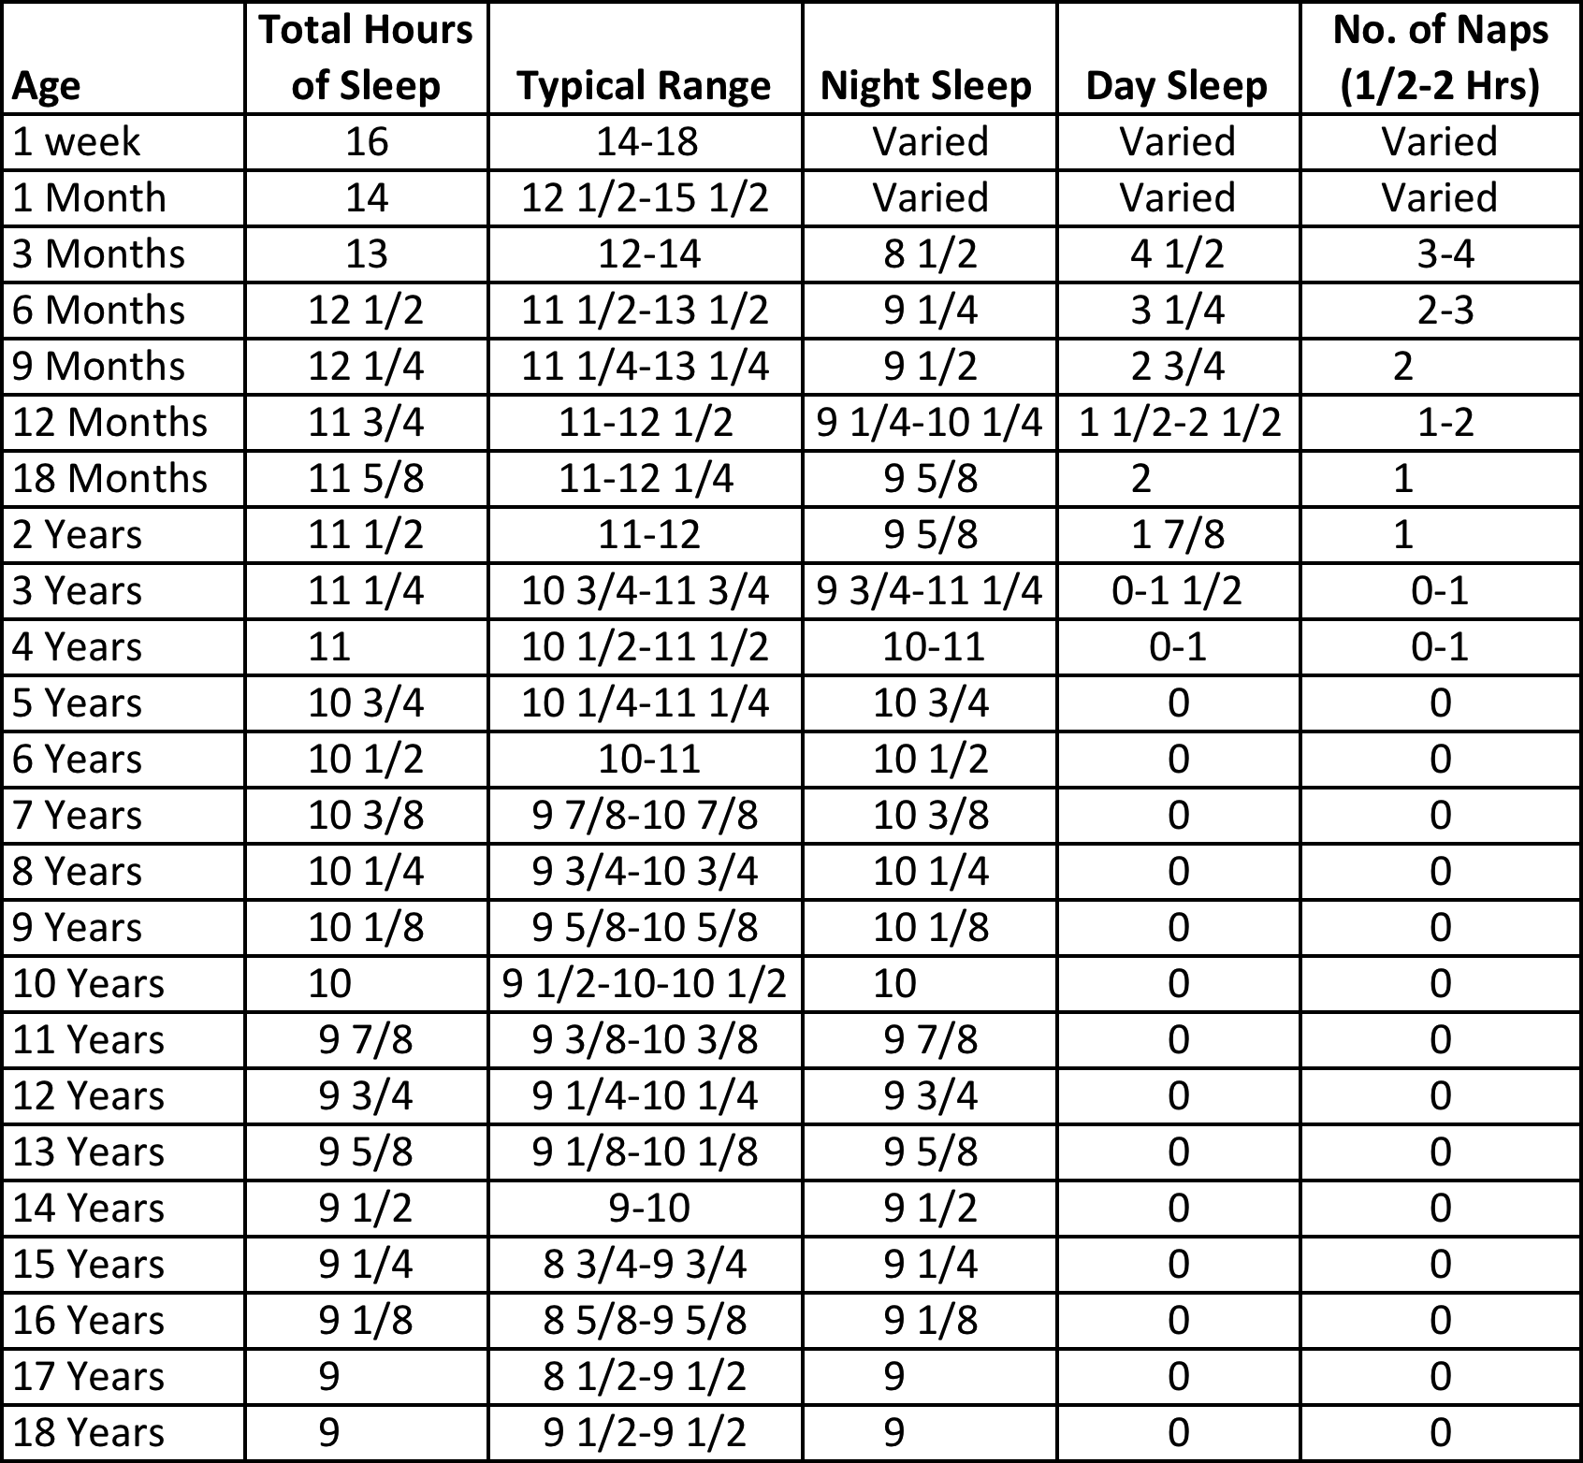

Most children drop napping somewhere between their third and fourth birthdays. If your child is getting one to two hours more or less sleep than the amount shown above, you should consider adjusting their sleep schedule If you decide you do need to make an adjustment, the rest of this book summary will give you some helpful tips and advice on how to accomplish the adjustment.

Helping Your Child Develop Good Sleep Practices

Common sleep routines are very important for your child. Developing good sleep patterns early on will help you avoid problems, as the child gets older. For example, if you get into the habit of rocking your child to sleep or rubbing their back, and you need to repeat the ritual once or twice in the middle of every night, you may actually be interfering with the child’s sleep and delaying their ability to sleep through the night. It is in the child’s best interests to be able to sleep through the whole night. If your child hasn’t started sleeping through the entire night by five or six months, then you should take a close look at the bedtime routines. Putting down the child awake can help the child learn to settle themselves and fall asleep alone both at bedtime and after nighttime wakings. Common routines can include changing into pajamas, brushing teeth, and bedtime stories. Set aside ten to thirty minutes doing something special with your child before bed. Avoid teasing, wrestling, scary stories, and anything else that will excite your child. Let your child know that your time together before bedtime together is fixed and once up, that they need to go to sleep.

Should you co-sleep?

Co-sleeping is another common topic with both potential advantages and disadvantages to consider. It is up to you if you want to co-sleep in the same room but here are some points to consider:

Advantages:
- Constant closeness whenever the child is awake.
- Immediate support for any nighttime separation concerns or other anxieties.
- The ability to nurse, and to respond to their nighttime waking; quickly, and without getting up.
- More time spent with the child.
- Possibly better sleep for both the child and the parents, if the child was sleeping poorly to begin with.
Disadvantages:
- There may be a slight increase in the risk to the infant from SIDS and related causes.
- Parents may sleep poorly if their children are restless sleepers.
- Parents may end up sleeping in separate rooms, and they may become angry with their child or at each other.
- Children’s and adult’s sleep cycles do not coincide.
- Parents may have to go to bed at a very early hour, with their children, and be left with little time for their own evening activities and inability to use a babysitter for even the occasional night out.
- Certain sleep problems that arise may be more difficult to correct.
- Parents have little privacy.

The Nighttime Crying Problem

The pacifier is a somewhat controversial topic with many opinions. Dr. Ferber recommends it is best to not use one for putting your child to sleep at bedtime. A child may likely cry when the pacifier is missing, and will cry until it is replaced.

The general guideline to follow is: Your child needs the same environment that they fall asleep in, to be the same environment when they wake up in. When your child wakes periodically during the night, as most children do between sleep cycles, most will promptly fall back asleep, because the conditions they associate with falling asleep are still present. But if the conditions have changed, some children may not be able to fall asleep again without help reestablishing them.

How to Solve the Problem: The Progressive-Waiting Approach

Almost anything can become associated with falling asleep. Examples include: feeding, sucking on something, being rocked, back rub, being petted or walked, or driven around in car, lullabies; videos, music; and fans or white-noise generators. Even simple tuck-ins and goodnight kisses can become a problem if they need to be carried out repeatedly at bedtime and again during the night. Fortunately, it doesn’t take most children very long to learn to give up old habits and take on new and better ones. Think again about having to sleep without your pillow. If you personally had to start sleeping without it regularly, for health reasons, you would probably find it difficult at first. You would be uncomfortable and may thrash around. The only way to learn to do it would be to practice falling asleep over and over. It would become easier each time and eventually you would feel normal and fine to sleep without it. At this point your nighttime wakings would cease to be a problem. Children are the same way. A child will likely need to be alone in a crib, and learn to fall asleep at bedtime under the same conditions that would be present when he woke up spontaneously during the night. The goal is to leave while the child is still awake. And repeat every night. Each night wait a longer period before coming in to comfort your crying child.

Number of Minutes to Wait Before Responding To Your Child

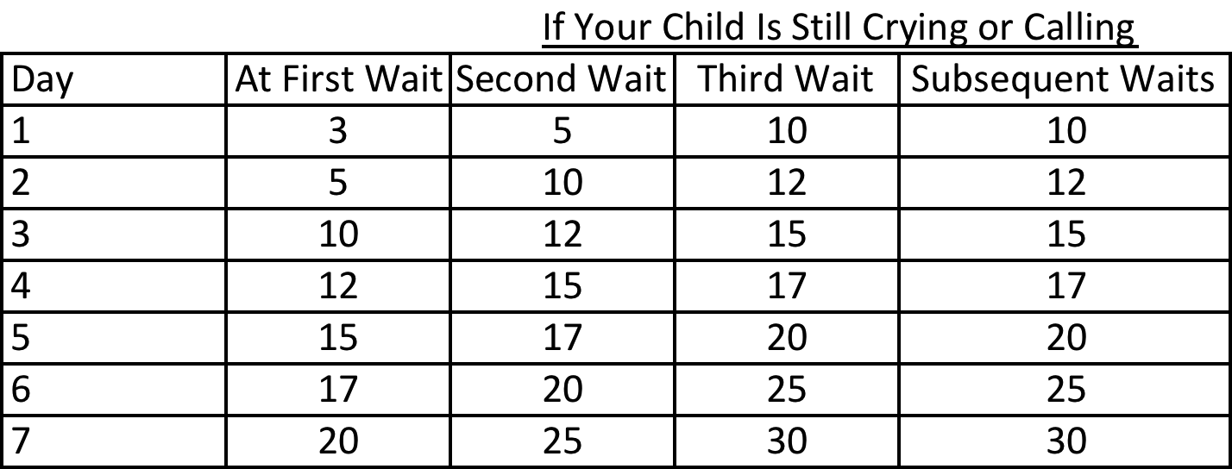

- Pick a starting bedtime no earlier than the time your child usually falls asleep, even if that is later than his usual bedtime. You may find that making the bedtime thirty to sixty minutes later than usual for the first several nights may help. The morning waking time should not be moved later, and naps should be kept at normal length.
- Put your child in the crib awake, with the same circumstances that will be present when the child wakes up in the night and the next morning.
- If the child cries for you, check on them briefly at increasing intervals per the chart above.
- By the third or forth day your child will most likely be sleeping very well. If not continue the chart till day 7. Add a few minutes to each interval if necessary.
- Each time you go to your child, spend no more than one or two minutes. Your job is to reassure them, not to get them to stop crying.
- If your child wakes during the night, restart the schedule with the minimum waiting time for that night and work up to the maximum again from there. Continue this routine after each waking until a time in the morning (usually 5:00am to 6:00am) after which it is unlikely that your child will fall back asleep, even if it is earlier than he usually has been awake. The entire night’s sleep should be in one location. If he is still sleeping in the morning, wake him up.
- If your child sleeps in a bed in their own room but will not stay there, put a gate on the doorway (making his whole room a crib) and return to the gate at increasing intervals.
- Use the same waiting schedule for naps. If your child has not fallen asleep after half an hour, or if he is awake again and calling or crying vigorously after even a short period of sleep, end that naptime. The child may just fall asleep at a later naptime. The amount of time napping should not be allowed to increase. It’s also a good idea to not let naps run past 4:00pm, which will interfere with falling asleep at night.
- Chart the sleep patterns.
Better sleep comes only when your child learns to fall asleep and return to sleep without your intervention, and that happens only when the child gets practice. Remember, the child needs to fall asleep on his own. If the child has a pacifier in their mouth the whole day, it will be hard to stop at night. There is no good way to eliminate nighttime use of the pacifier gradually. You must do it “cold turkey.”

General Observations
The conditions associated with falling asleep should not be stimulating, like TV, and they should not involve activities such as sucking on a bottle or pacifier. It’s best to have the room dark and quiet with no lullaby CD’s or noisy machines. After the first few months, children should not need to be rocked, held, patted, or soothed with a bottle or pacifier; they will just to fall asleep. Bedtime feedings are fine even after the early months as long as the child doesn’t come to depend on them to fall asleep during the night.

When children wake during the night, they should be where they were when they fell asleep, with the same people there (or not there); they should be able to trust that no changes were made after they fell asleep.

You can start the progress-waiting approach after your child is three or more months old. Most children start to sleep on their own through the night within three or four months after birth. Newborns do not sleep through the night and you should not make them. A full night is too long for a newborn to go between feedings. Since it is important to follow through on the program consistently, you should wait for a convenient time to begin. Don’t start the night before an important interview or an important meeting. You may want to start on a Friday night of a long weekend. In two-parent households, it’s important to share the responsibilities as much as possible, so that your child will feel comfortable with either parent at bedtime and after wakings.

Setting boundaries and limits

A strategically placed gate at the top of the stairs or in the hallway can help keep your child in a restricted part of the house and safe. Remove any chairs or stools that your child could use to climb over it. You must behave consistently for the plan to work. Just like the inside of a crib, the room must be safe as well with windows locked or protected, outlets covered, no sharp-edged furniture or long strings. For a child who is too big for a gate, usually between the ages of four to six years old, you may have to close the door. Each time the child leaves the room, take him back and close the door.

Stickers and point charts- Positive Reinforcement

Start your reward program by negotiating with your child, when he is three years or older. It is harder to implement when the child is under three years of age. Offer two stickers for quietly staying in the room at bedtime, one if he calls out but doesn’t leave the room, and three if he stays in bed all night. For three-year-olds, the stickers are their own reward. Older kids may need something more. A child who feels he can’t earn his rewards will simply stop trying.

Another cause of trouble is nighttime feedings. Once your baby is about three months old, she should not require more than one feeding during the night (in addition to the bedtime feeding), and that last nighttime feeding will probably be given up at some point over the next month.

Nighttime Fears
Most children will feel frightened at nights and these fears can lead to sleep problems, as the child does not want to be alone. Strategies to help include: emotional support, desensitization, rewards, schedule adjustments, negotiation, unlearning of automatic behavior, and limit setting. Causes of stress can include: illness, parental fighting, separation, divorce, alcoholism, substance abuse, thunder storms, parent’s absence due to a trip, last night’s television show, school bully, an unsympathetic teacher, an upcoming exam, and death in the family. There are different levels of being “scared.” Not all complaints of being scared should be handled the same way. Some children who are forced to go to bed at the wrong time will call out to the parents with a variety of excuses.

Here are some questions to consider:

When your child says he’s scared, does he look and act frightened?
Is he really having bad dreams?
Is he fully awake?
Is he testing limits?
Is he just not sleepy?
How intense are the fears at night?
Is the anxiety present all day or just at night?
Does he have trouble separating in the daytime?
Is the anxiety of long standing or is it a recent development?
Is there an identifiable external cause to his fears?
Does he seem to be frightened by many things or is she just afraid of a few specific ones?
Is he afraid of “monsters” and “robbers?”
Is he afraid of the dark? (Few children like to sleep in total darkness and there should be a dimly lit night-light to help.)
Is he afraid of having her door closed? (Most children want the doors at least ajar at night.)
Is there a self-reinforcing pattern to the fear?

How to cope with nighttime fears

If your child isn’t really frightened, stick with the normal bedtime routine. Do not return repeatedly after every noise. By about age five, he is likely to wake from a dream with an immediate and full understanding that he has been dreaming.
For a two year old, soothing and reassuring words can help. For a three to four year old, it may be useful to remind him he has been dreaming, with empathy and reassurance. He may want to sleep with a night-light. The main thing to always remember is that he will need comforting and support.

For very mild fears- be sympathetic, reassuring, and supportive. Reassure the child firmly and calmly that he is safe and that you will take care of him; then put him to bed with the usual story or quiet talk. For more substantial fears- your goal is to do whatever you have to do take away the anxiety. Help the child feel safe and able to sleep well during the night. Try to determine how much support the child needs and offer it freely. He must know that he can get help without angering or upsetting you.

Techniques to help a child feel less frightened and fall asleep quickly:

- Arrange for an enjoyable time in his bedroom. Spend time doing fun things in his room during the day. The final bedtime routine should take place in his bedroom.
- Move his bedtime later temporarily.
- Use stickers or other prizes as positive reinforcement.
- Teach your child to practice dealing with waking and mild anxieties alone.
- Talk to your child; ask him what he needs.
- Set appropriate limits.
- Leave lights on and doors open.
- Agree to check on your child periodically. Explain that you will continually check on him through the night. Make the initial intervals about 5 minutes.
- Agree to stay upstairs until she is asleep. It is best to have both yours and the child’s bedrooms on the same floor of the home.
- Agree to stay up later than he does.
- Sit in his room. You can gradually move your chair closer to the door.
- For a child who has severe anxiety, you can sleep in his room. You can sleep in a separate bed or on a mattress. The goal is for him to know and trust that you are there when he falls asleep and will still be there whenever he wakes. If you try to sneak back to your own room whenever he is asleep, you will undermine the trust and he will start trying to stay awake or reawakening frequently to check on you.
Do not use siblings or pets to do your job as a parent. Often trial and error will show you what works or what changes have to be made. If you aren’t making progress, or if the progress stops, you may need professional help to decide how serious your child’s anxiety is; whether your behavioral program should continue, and whether counseling is needed.

Most children past the early months of life sleep no more than eleven to thirteen hours total, including naps. They rarely sleep more than eleven hours at night. If they nap long periods, then they won’t sleep more than nine or ten hours at night. The more they nap, the shorter their nighttime sleep is likely to be. Most school-age kids having given up naps altogether, and sleep between nine and eleven hours at night. Fourteen hours of sleep is just not likely. Most children stop napping altogether between their third and fourth birthdays, but some two-year-olds have already given up their last nap, and some children continue napping until the start of kindergarten.

Bed-wetting
Bed-wetting, also called nocturnal enuresis is a very common and frustrating childhood sleep problem that can upset parent and child alike. Your reactions are very important. Without your understanding and support, your child will surely suffer. Explain that he is not at fault and you are not mad at him.

There are many factors that can cause bedwetting including the following: heredity, maturation, small bladder capacity, nighttime awareness of the need to urinate, depth of sleep, medical issues, food sensitivity, emotional factors, and environmental and early childhood influences.

Most children are dry at night before age four, but this can vary. A child’s bladder grows considerably between the ages of two and four and a half, making it easier to hold urine during the night. A few babies can be dry at night before their first birthday. By about 2 ½, about half of all children are dry and by age three about three out of four no longer wet their beds.

There are four main techniques that may help:
- Reinforcement and responsibility training
- Bladder training
- Conditioning and
- Medication
Do not restrict your child’s fluid intake during the day; it will not help. A child should not be sleeping in diapers at night if she is past her fourth birthday and definitely not if she is already five years old. You can use a water—proof pad under the bed sheet to protect the mattress. Set up a system to record and reward dry nights. A sticker chart on a calendar can work. You can also practice bladder start and stop exercises. Conditioning devices can be used, and rely on a sensor that fits into the child’s underwear at night. When it gets a wet, a loud alarm (usually attached to the child’s pajamas or wrist) is triggered. Your child will be awaken when she begins to wet the bed to hopefully gradually come to unconsciously associate the sensations he feels just before urinating with the need to wake. This should be used when he is at least seven. This treatment may last up to five months but generally works before that. Lastly, a common medication used is Desmopressin. Check with your doctor for more information.

Work with him positively, as part of a team. If you do that, you will help him avoid months or years of unnecessary suffering, his self-image will improve, your own relationship with him will remain unharmed, and he will get along better with his friends.

Concluding General Advice

- Ensure adequate sleep.
- Keep to a regular sleep schedule.
- Eliminate nighttime jobs and habits.
- Provide a pleasant structured bedtime.
- Avoid bedtime activities that your child may try to resume on waking.
- Set an appropriate bedtime, late enough for your child to fall asleep quickly
- Make any necessary changes to keep your child safe.
- All people need to have a similar sleep pattern for the weekdays and the weekends.
- Especially for teenagers, driving under the influence of sleep deprivation and alcohol can be very dangerous. Just one beer can be extremely harmful and have cumulative effects to a sleep deprived teenager.
- Keep the TV and computer in the main living room, not your kids room. They will want to stay up very late and that will hurt their sleep. Screen time should also not be the last thing they do right before bed. Don’t make late-night TV a special weekend privilege either. Record late shows when necessary.
- Keep mealtimes at similar times every day.
About the author:
Lily Talley is the owner and director for Seattle Learning Center, with over 10 years of experience in teaching. Seattle Learning Center is a childcare center and preschool located in the Queen Anne neighborhood of Seattle, Washington. The school focuses on education, creativity and physical fitness. If you would like to learn more, please visit www.seattlelearningcenter.com or call 206-673-3080. We look forward to serving you.

Feel free to share this article with anyone who will benefit. Please keep the content unaltered and in its complete and original form. Thank you!

Source:
Ferber, Richard. Solve Your Child’s Sleep Problems. New York: Simon & Schuster, 1985.

